Why Iran is attacking US bases in the Gulf rather than focusing on Israel
ITV News
Sat, 28 February 2026 at 11:14 pm SGT
2 min read
Add Yahoo as a preferred source to see more of our stories on Google.
Add Yahoo on Google
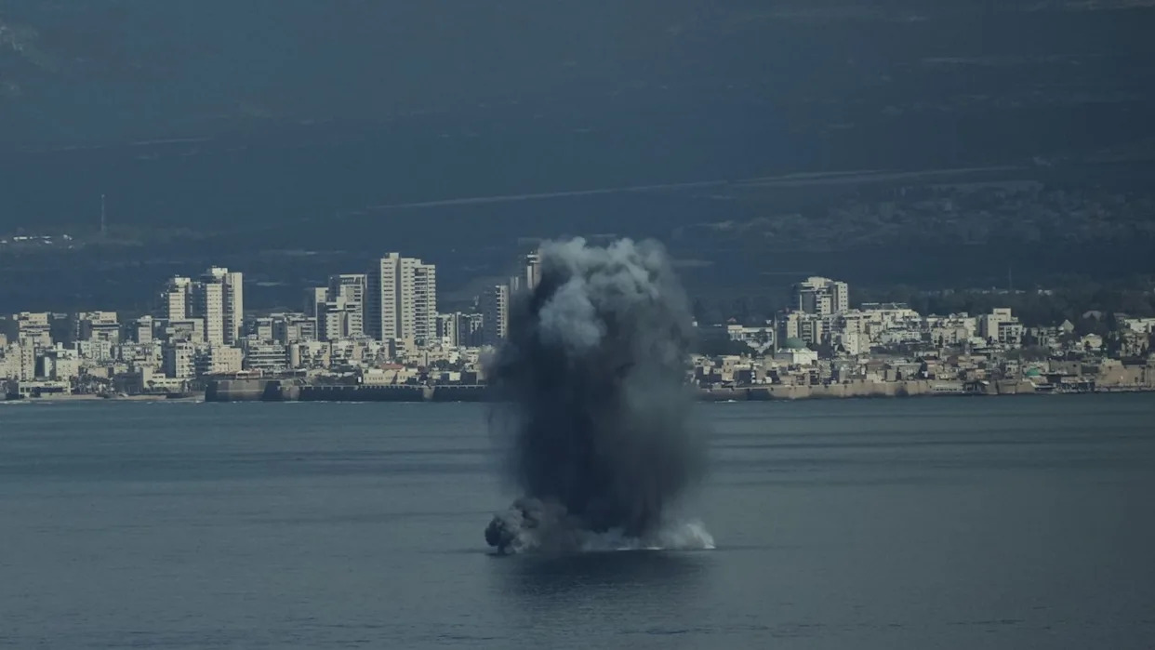
So far the unprecedented aspect about this, the third Gulf War, is the Iranian targeting of several US bases in the Gulf. We’ve seen big plumes of smoke blossom as Iranian missiles slam into near neighbours like Bahrain and Abu Dhabi.
Here in Tel Aviv the air raid sirens have been frequent but the missile salvoes smaller than those sent this way last June. They have come in by the dozen rather than hundreds.
The Israeli/US umbrella of interceptor missiles defending this country is unrivalled. During June’s 12-day war they shot down 85% of the Iranian ballistic missiles that they tried to intercept.
Of course Iran could be holding back a more potent threat. Or they may have made the strategic decision to focus on the Americans more than the Israelis.
From their point of view why strike Little Satan when the Great Satan is closer by and perhaps more poorly defended? The Gulf targets may provide more bang for their buck.
The Iranians know that their ultimate currency in this war is dead Americans.

Subscribe free to our weekly newsletter for exclusive and original coverage from ITV News. Direct to your inbox every Friday morning.

Whatever damage Iran is able to inflict abroad, it’s undoubtedly far less than the damage being sustained at home.
Last June, the Israelis paved the way for American B2 bombers to attack three nuclear sites unchallenged.
The Iranian air defence system was beaten to such an extent that in the end Israeli jets were flying over Tehran in broad daylight.
But while Iran is struggling to defend itself, it can still retaliate. American fatalities will test President Trump’s resolve.

